**EVENT PLAN LINE TABLE**

***CREATE TABLE SYNTAX :***

CREATE TABLE TABLE_NAME(<column-list>

[<constraint-list>]

);

CREATE TABLE EventPlanLine (

PlanNo VARCHAR2(8) CONSTRAINT EPLPlanNoNOTNULL not null,

LineNo INTEGER CONSTRAINT LineNoNOTNULL not null,

TimeStart DATE CONSTRAINT TimeStartNOTNULL not null,

TimeEnd DATE CONSTRAINT TimeEndNOTNULL not null,

NumberFld INTEGER CONSTRAINT NumberFldNOTNULL not null,

LocNo VARCHAR2(8) CONSTRAINT EPLLocNoNOTNULL not null,

ResNo VARCHAR2(8) CONSTRAINT EPLResNoNOTNULL not null,

CONSTRAINT FK1_EPLPlanNo1 FOREIGN KEY(PlanNo) REFERENCES

EventPlan(PlanNo),

CONSTRAINT FK1_EPLLocNo1 FOREIGN KEY(LocNo) REFERENCES Location(LocNo),

CONSTRAINT FK1_EPLResNo1 FOREIGN KEY(ResNo) REFERENCES ResourceTbl(ResNo),

CONSTRAINT CheckTimeLine

CHECK(TimeStart<TimeEnd)

);

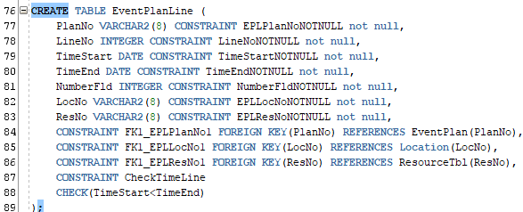

***INSERT STATEMENT :***

INSERT INTO TABLE_NAME(col_1,col_2,…col_n) VALUES (exp_1,exp_2,……exp_n);

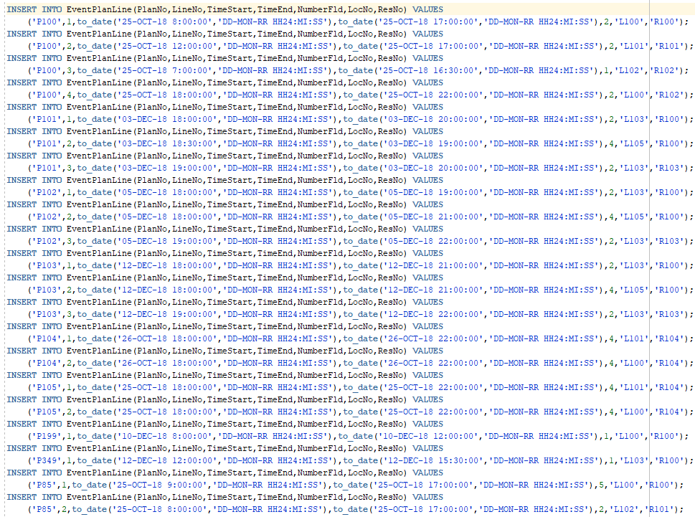

***SELECT STATEMENT :***

SELECT * FROM TABLE_NAME;



***OUTPUT :***

